**Fake Product Detection in E-Commerce Platforms Using Block-Chain Technology**

Dr. K. DANESH

Project Mentor, Department of Information Technology, SRM Institute of Science and Technology, Ramapuram

ATHIRA P

UG Student, Department of Information Technology, SRM Institute of Science and Technology, Ramapuram

SREE DURGA DEVI S

UG Student, Department of Information Technology, SRM Institute of Science and Technology, Ramapuram

ANISHA K

UG Student, Department of Information Technology, SRM Institute of Science and Technology, Ramapuram

**Abstract:** The growing presence of counterfeit products on e-commerce platforms is a major concern, causing significant financial losses for businesses and eroding consumer trust. Fake goods not only tarnish a brand’s reputation but can also put consumer safety at risk, especially in critical industries like pharmaceuticals, electronics, and luxury items. To tackle this issue, there is a pressing need for a transparent and reliable system that can verify product authenticity and build stronger trust between buyers and sellers. This study explores how blockchain technology can be leveraged to prevent counterfeiting. By using smart contracts, products are registered on a decentralized network, each assigned a unique digital identity. A QR code-based system is then used, allowing consumers to easily verify a product’s authenticity before purchase. Blockchain’s core strengths—security, transparency, and immutability—make it a promising tool in the fight against counterfeit goods. However, challenges such as scalability, interoperability between different systems, and the high costs of implementation still need to be addressed. Despite these obstacles, the research underlines the strong potential of blockchain technology to safeguard consumer interests and preserve brand value in the e-commerce space.

**Keywords**: Blockchain, Decentralization, Ethereum, Smart Contracts, Product Verification, QR Code Authentication, E-Commerce Security

.

I. INTRODUCTION

Fake product detection using blockchain leverages decentralized and immutable ledger technology to enhance transparency and security in product authentication. By recording each product’s origin and tracking its journey through the supply chain, blockchain ensures tamper-proof verification, reducing the risk of counterfeit goods. Every transaction in the supply chain is immutably stored, enabling real-time verification and fraud prevention.

This paper proposes a blockchain-based counterfeit detection system that assigns unique digital identities to products, allowing consumers to verify authenticity before purchase. The system aims to protect consumers and brands, secure company revenue, ensure regulatory compliance, and support ethical practices. A QR code-based authentication mechanism allows consumers to access product details instantly, enhancing trust and transparency. For example, in the cosmetic industry, blockchain can store details like origin, production date, and supply chain data. If discrepancies arise, such as mismatched production locations, businesses can quickly identify counterfeit items. This approach outperforms traditional anti-counterfeiting measures by providing real-time monitoring and instant verification.

Additionally, this paper critically evaluates the challenges and limitations of blockchain-based authentication, such as scalability, integration with existing systems, and adoption barriers. It also explores future developments and recommends research directions to further enhance blockchain’s role in counterfeit detection. Overall, blockchain presents a transformative solution for businesses and consumers, ensuring product authenticity, enhancing trust, and preventing fraud in global markets. companies can efficiently monitor and eliminate counterfeit goods with minimal effort.

**A. BLOCKCHAIN**

Blockchain is a **decentralized digital ledger** that securely records transactions across a network of computers. Each transaction is stored as an immutable block linked cryptographically to previous blocks, ensuring **data integrity and security**. Since records cannot be altered without modifying subsequent blocks, blockchain provides a **transparent and fraud-resistant system** for counterfeit detection.

**B. ETHEREUM**

Proposed by **Vitalik Buterin in 2013**, Ethereum extends blockchain beyond financial transactions, enabling **decentralized applications (dApps)** through **smart contracts**. These contracts automate processes such as product verification, making Ethereum a suitable platform for anti-counterfeiting solutions.

**C. COUNTERFEIT PRODUCTS**

Counterfeit goods are unauthorized imitations of genuine products, designed to mislead consumers and exploit brand value. They include **fake currency, documents, luxury items, and consumer goods**, often leading to financial losses and safety concerns.

**D. HOW BLOCK-CHAIN ADDRESSES COUNTERFEITING**

Blockchain ensures **product authenticity** through a **five-step process**:

* **User authentication** for transaction validation.
* **Creation of a new block** with transaction details.
* **Distribution of the block** across the network.
* **Verification and linking** to the existing blockchain.
* **Continuous synchronization** across the network.

This process ensures **secure, immutable, and transparent** tracking of products, significantly reducing counterfeiting in e-commerce.

**E. BENEFITS OF BLOCKCHAIN**

1. Accuracy – As a distributed system, blockchain minimizes human intervention, reducing errors and enhancing data accuracy. Each transaction is verified through computing protocols, ensuring reliability.
2. Cost Reduction – Blockchain eliminates intermediaries like banks, reducing transaction fees. Unlike credit card payments, where fees apply, blockchain transactions have minimal or no costs due to its decentralized nature.
3. 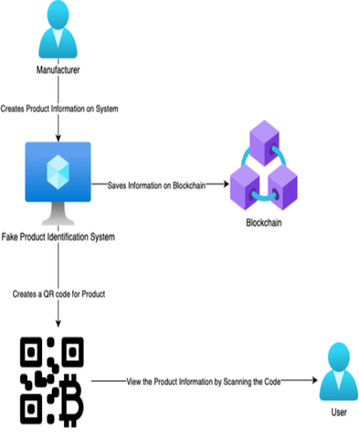Decentralization – Data is stored across multiple network nodes, making it highly secure. Even if a hacker alters one copy, the rest remain unchanged, ensuring data integrity and protection.
4. Efficient Transactions – Unlike traditional banking systems that operate during business hours, blockchain runs 24/7, enabling transactions to be completed in minutes, regardless of time zones or geographical barriers.
5. Transparency – Blockchain is an open-source technology where all transactions are visible and verifiable. Any updates require majority consensus, ensuring fairness and preventing unauthorized changes.

# II. OBJECTIVE

The primary objective of this blockchain-based solution is to guarantee immutability by securely recording product data using cryptographic hashing, ensuring a tamper-proof system that prevents unauthorized modifications while maintaining data integrity and security. By providing a reliable product verification mechanism, the system enhances authenticity and trust in counterfeit detection, ultimately increasing consumer confidence in online shopping by reducing the presence of fake products. Additionally, the solution aims to enhance supply chain transparency by enabling real-time tracking of products from their origin to the end consumer. s and legal frameworks for product authentication.

Through decentralized verification, multiple stakeholders, including manufacturers, retailers, and consumers, can independently verify product authenticity, reducing financial losses for businesses and brands caused by counterfeit goods. Moreover, this approach improves consumer

awareness by providing easily accessible and verifiable product information through blockchain-based QR codes or digital certificates. By leveraging smart contracts, the system increases efficiency in fraud detection by automating counterfeit identification and alerting stakeholders in case of discrepancies. Furthermore, it supports ethical and sustainable practices by promoting responsible sourcing and eliminating fraudulent supply chain activities, making blockchain a powerful tool in combating counterfeit products.

# III. LITERATURE REVIEW

A key consideration when developing a counterfeit product detection system is understanding the need for secure and reliable authentication methods in e-commerce platforms. The rapid growth of online marketplaces has led to an increase in counterfeit goods, affecting both businesses and consumers. Traditional product authentication methods, such as QR codes, barcodes, and holograms, are often vulnerable to replication and tampering. These existing solutions rely on centralized databases, which can be manipulated, making them ineffective in ensuring product authenticity. To address these challenges, blockchain technology offers a decentralized, immutable, and transparent approach to counterfeit detection. Blockchain technology functions as a distributed ledger that records transactions securely using cryptographic hashing and consensus mechanisms. Unlike conventional databases, blockchain prevents unauthorized alterations, ensuring the integrity of product data. By leveraging smart contracts, blockchain can automate and enforce verification protocols, enabling real-time validation of product authenticity. This eliminates dependency on intermediaries and reduces the risk of fraudulent activities in online transactions.

The integration of blockchain in counterfeit detection enhances supply chain transparency by providing end-to-end traceability. Each product can be assigned a unique digital identity, which is recorded on the blockchain at various stages of the supply chain. Consumers can verify the authenticity of a product by scanning a blockchain-registered code, accessing its entire transaction history. This process increases consumer confidence and minimizes financial losses associated with counterfeit goods. The adoption of blockchain for counterfeit detection in e-commerce platforms presents several advantages, including improved data security, reduced fraud, and enhanced trust among consumers and retailers. Future research should focus on optimizing blockchain frameworks for large-scale e-commerce operations, ensuring seamless interoperability with existing supply chain infrastructures, and improving energy efficiency in blockchain networks.

# IV. EXISTING SYSTEM

Existing counterfeit product detection Existing counterfeit detection systems rely on manual inspections and automated methods like QR codes and barcodes, which are prone to tampering and inefficiencies. Counterfeit goods cause financial losses, damage brand reputation, and pose safety risks, especially in industries like pharmaceuticals and electronics. Consumers often depend on centralized verification systems, increasing the risk of fraud. Manual checks are error-prone, and automated systems struggle with evolving counterfeiting tactics. Additionally, verifying product authenticity often requires consumers to rely on merchants, manufacturers, or centralized databases, which increases the risk of manipulation and misinformation. Manual inspections are time-consuming and prone to human error, while automated systems often struggle to adapt to evolving counterfeit strategies. The absence of real-time detection mechanisms further exacerbates the issue, as counterfeit products may enter the market undetected until consumers or businesses identify anomalies. Given these challenges, there is a growing need for an advanced, decentralized, and tamper-proof solution that enhances real-time counterfeit detection, ensures supply chain transparency, and strengthens consumer protection against fraudulent products.

**V. METHODOLOGY**

This system employs blockchain technology for decentralized and tamper-proof product authentication. Each product is assigned a unique QR code linked to its blockchain record, storing manufacturing details, ownership history, and supply chain transactions. The system promotes transparency, collaboration with stakeholders, and continuous updates to enhance counterfeit detection.

* 1. **PROPOSED SYSTEM**

The proposed system utilizes **blockchain technology** and QR **codes** to efficiently detect and prevent counterfeit products. A **decentralized blockchain ledger** records each product’s history, including manufacturing details, shipping records, and ownership, ensuring transparency and tamper-proof authentication. Each product is assigned a **unique** QR code, linking it to its blockchain record, enabling consumers and retailers to verify authenticity instantly. Upon scanning the QR code, users can access detailed product information, such as origin, manufacturing date, authorized distributors, and certifications, helping them validate authenticity and report any discrepancies. To enhance security, **anti-tampering mechanisms** such as smart tags or seals detect unauthorized modifications, raising alerts for potential counterfeit products. The system is supported by a **mobile application** that allows users to scan QR codes, receive real-time alerts, check product reviews, and report suspicious items, facilitating an easy and reliable verification process for both consumers and retailers. Furthermore, the system promotes **collaboration between manufacturers, regulators, and law enforcement agencies**, enabling them to analyze counterfeit trends and take preventive actions.

**5.2 SYSTEM DESIGN**

The architecture of the proposed counterfeit detection system is designed to ensure **secure product authentication** using **blockchain, QR codes, and machine learning**. The system follows a **decentralized and scalable approach**, integrating **frontend, backend, blockchain, and database components**.

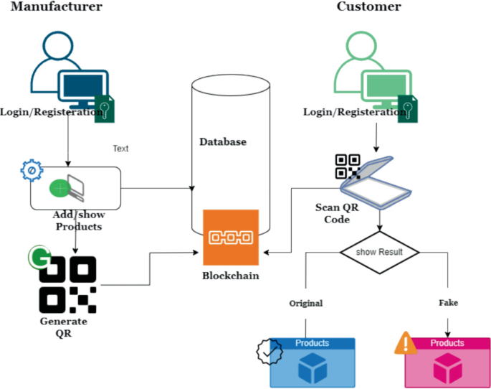

## 5.3 PROJECTS REQUIREMENTS

* **Programming Languages**
* **Python: Used for processing data, implementing blockchain logic, and integrating machine learning models. It offers extensive libraries for data analysis, image processing, and backend development.**
  + **Frameworks**
* **Web3.js: A JavaScript library used to interact with Ethereum-based blockchains, enabling transactions, smart contract interactions, and blockchain data retrieval.**
* **Flask / FastAPI: Backend frameworks for building APIs that connect the frontend, blockchain, and database. FastAPI provides high performance with asynchronous capabilities, while Flask is lightweight and easy to implement.**
* **React.js: A JavaScript library for building interactive user interfaces, primarily used for the frontend to enable seamless user interactions.**
* **Blockchain Tools**
* **Ethereum: A decentralized blockchain network that supports smart contracts and decentralized applications. It is used to implement product tracking and verification.**
* **Hyperledger Fabric: A permissioned blockchain framework suitable for enterprise applications, offering modular architecture and better scalability for product authentication.**
* **Databases**
* **MongoDB: A NoSQL database that efficiently stores product information, blockchain transaction records, and user feedback. Its flexible document-based structure is ideal for handling unstructured data.**
* **API & Libraries**
* **QR Code API: Used for generating and scanning QR codes, linking products to blockchain records for verification.**
* **OpenCV / TensorFlow:** 
  + **OpenCV: A computer vision library used for QR code detection, image processing, and counterfeit product analysis.**
  + **TensorFlow: A machine learning library that can be used for product authentication by analyzing patterns and detecting anomalies.**
* **Data Processing & Analysis Libraries**
* **Pandas: A data analysis library for handling structured data, performing data cleaning, and processing product records.**
* **NumPy: Used for numerical computations, matrix operations, and statistical calculations.**
* **Scikit-learn: A machine learning library for training fraud detection models and analyzing counterfeit patterns.**
* **Hardware (Optional)**
* **QR Code Scanner: A device used for scanning product QR codes, enabling users to verify authenticity through blockchain records.**
* **Testing & Deployment**
* **Postman: A tool for API testing, ensuring proper communication between the backend, blockchain, and frontend.**
* **Mocha: A testing framework used for validating backend logic and smart contract functionalities.**
* **Docker: A containerization platform that enables seamless deployment of the application across different environments with consistency.**
  + **Smart Contracts**
* **Solidity: A programming language used to write smart contracts on Ethereum, defining product ownership and verification rules.**

**This combination of tools ensures a robust, scalable, and secure blockchain-based counterfeit detection system**

# VI. PROJECT MODULE

* + - **User Authentication & Registration**
* **The system implements secure user authentication using Multi-Factor Authentication (MFA) to enhance security.**
* **Role-based access control (RBAC) ensures that buyers, sellers, and administrators have specific permissions and access levels.**
* **Users can register and log in securely, protecting sensitive data and transactions from unauthorized access.**
* **Product Registration via Blockchain**
* **Each product is assigned a unique digital identity stored on the blockchain.**
* **A smart contract is executed to record product details like manufacturer information, production date, and batch number.**
* **This registration ensures that products cannot be altered or duplicated, providing a tamper-proof record.**
* **QR Code Generation & Verification**
* **The system generates unique QR codes for each registered product, linking directly to the blockchain records.**
* **These QR codes are secure and immutable, preventing counterfeiting or tampering.**
* **Users can scan the QR code via a mobile application or web interface to verify the authenticity of the product.**
* **Decentralized Product Ledger**
* **A distributed ledger (using Ethereum or Hyperledger Fabric) maintains a transparent and tamper-proof record of all product transactions.**
* **The ledger allows real-time tracking of ownership changes, preventing unauthorized modifications.**
* **Buyers can trace product history, including previous owners, manufacturing details, and transaction timestamps.**
* **Smart Contract Execution**
* **Ethereum-based smart contracts automate product validation, ensuring that only genuine products are transacted.**
* **The contracts execute trustless and decentralized transactions, eliminating intermediaries and reducing fraud risks.**
* **A verification process ensures that every scanned product matches its blockchain-stored details.**
* **Counterfeit Detection Mechanism**
* **The system utilizes AI-powered analysis (OpenCV & TensorFlow) to identify anomalies in product packaging and labeling.**
* **Scanned product images are analyzed to detect unauthorized alterations, verifying their authenticity against blockchain data.**
* **Blockchain verification further cross-checks QR codes and transaction history, ensuring genuine product validation.**
* **E-commerce Platform Integration**
* **The blockchain verification system is integrated with online marketplaces (such as Amazon, eBay) using APIs.**
* **This integration allows buyers to verify product authenticity directly on e-commerce platforms before making a purchase.**
* **Sellers can register products through the marketplace, ensuring a seamless and verified supply chain.**
* **Analytics & Reporting Dashboard**
* **A real-time analytics dashboard provides insights into counterfeit detection and product authenticity trends.**
* **The dashboard helps businesses take proactive measures against counterfeit products by monitoring risk factors and authenticity checks.**

# VII. Flow of the Proposed System

**1. Product Registration - Manufacturer**

**At the initial stage, the manufacturer registers the product on the blockchain to establish its authenticity and integrity.**

**Steps Involved:**

* **The manufacturer logs into the system through a secure authentication process with Multi-Factor Authentication (MFA).**
* **They navigate to the Product Registration Portal and enter the following details:** 
  + **Product specifications (model, brand, dimensions, material, etc.).**
  + **Manufacturing details (factory location, batch number, production date, expiration date).**
  + **Unique product identifier (serial number, hash-based ID).**
* **A smart contract is executed to create an immutable blockchain entry for the product.**
* **The system generates a unique QR code, cryptographically linked to the blockchain record, ensuring tamper-proof verification.**
* **The QR code is either:** 
  + **Physically attached to the product (e.g., sticker, engraving, embedded chip).**
  + **Digitally stored for tracking in the supply chain.**
* **The registered product is now permanently recorded in the blockchain, ensuring its authenticity from manufacturing to end-user delivery.**

**2. Supply Chain Integration - Distributor Networks**

**Once the product is registered, it enters the supply chain, where distributors handle its transit.**

**Steps Involved:**

* **The manufacturer ships the product to the distributor.**
* **Upon receiving the shipment, the distributor scans the QR code using a blockchain-integrated QR code reader or mobile app.**
* **The system records the following details on the blockchain:** 
  + **Distributor’s details (company name, location, unique identifier).**
  + **Ownership transfer (timestamp, recipient information).**
  + **Current status of the product (shipment received, verified, warehouse storage).**
* **Each scanned entry creates a new block in the blockchain, ensuring a transparent and immutable record of ownership transfer.**
* **The blockchain now stores a traceable product history, preventing unauthorized modifications.**

**3. Supply Chain Integration - Retailers’ Networks**

**After distributors, the product moves to retailers who prepare it for final sale.**

**Steps Involved:**

* **The distributor ships the product to the retailer.**
* **Upon arrival, the retailer scans the QR code, triggering another block addition to the blockchain.**
* **The system captures and records:** 
  + **Retailer’s ownership information (store ID, name, location).**
  + **Timestamp of transfer (date and time of receipt).**
* **The supply chain remains fully auditable, preventing unauthorized changes and counterfeiting.**

**4. Verification - End User**

**Customers or retailers can verify a product’s authenticity before purchase using a blockchain-enabled system.**

**Steps Involved:**

* **The customer accesses the blockchain verification system via:** 
  + **A dedicated mobile application.**
  + **A web-based verification platform.**
* **The customer scans the product’s QR code or manually enters the unique product identifier.**
* **The system retrieves detailed blockchain records, displaying:** 
  + **Manufacturer details (origin, production details, authenticity certification).**
  + **Supply chain journey (ownership transfers, timestamps, verified handlers).**
  + **Product integrity validation (check for tampering or duplication).**
* **If all records match, the customer confirms the product’s authenticity +-+before making a purchase.**
* **If discrepancies arise, the system alerts the user about potential counterfeiting.**

**5. Fake Product Detection**

**The blockchain-based system actively identifies and prevents counterfeit product circulation.**

**Steps Involved:**

* **Cross-verification with Blockchain:** 
  + **Users compare the physical product details with the blockchain record to detect mismatches.**
* **AI-Powered Image Recognition:** 
  + **Advanced AI algorithms analyze product images, packaging, and labels to identify irregularities.**
* **Automated Alerts for Fake Products:** 
  + **If discrepancies are detected, the system flags the product as counterfeit.**
* **Counterfeit Reporting:** 
  + **Customers and retailers can report suspicious products via the app or website.**
* **Investigation and Regulatory Action:** 
  + **System administrators, manufacturers, or regulatory authorities analyze the reported incident.**
  + **If confirmed counterfeit, legal actions are initiated against counterfeiters.**
  + **Alerts are shared with consumers, retailers, and distributors to prevent further circulation.**

**VIII. BENEFITS AND USE CASES**

**8.1 Advantages:**

* **Enhanced Security and Immutability** – Ensures tamper-proof, cryptographically secured, and decentralized records.
* **Transparency and Traceability** – Provides real-time tracking and verifiable product authenticity.
* **Prevention of Counterfeit Products** – Detects fake products early with unique product identities.
* **Increased Consumer Trust** – Allows buyers to verify authenticity before purchase, boosting brand reputation.
* **Cost Reduction and Operational Efficiency** – Lowers fraud-related losses and reduces dependency on third parties.
* **Improved Supply Chain Collaboration** – Enables seamless stakeholder integration and dispute resolution.
* 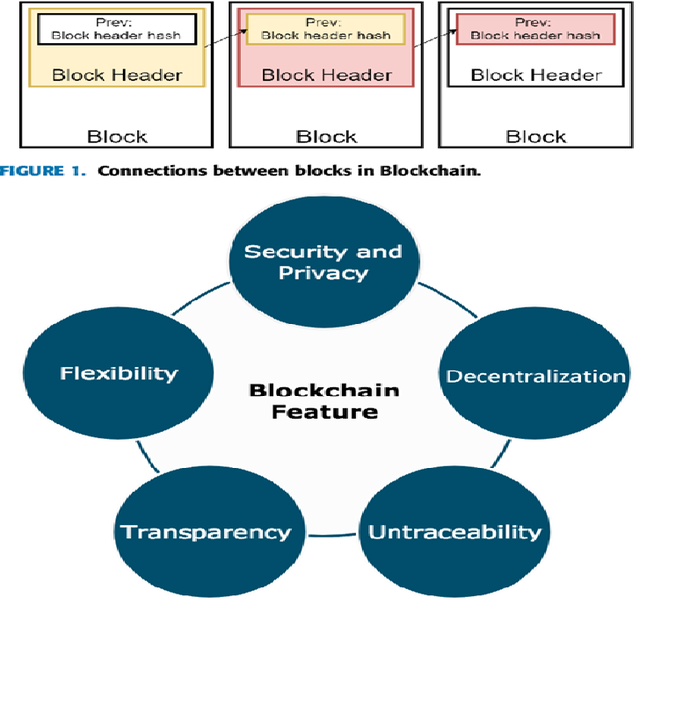**Scalability and Adaptability** – Works across industries and integrates with AI, IoT, and global supply chains.

**8.2 Applications**

**Detailed Applications of Fake Product Detection Using Blockchain Technology**

**1. Pharmaceuticals and Healthcare**

Blockchain enhances the pharmaceutical industry by ensuring the authenticity and safety of medicines and medical devices.

* **Counterfeit drug prevention** – Tracks the entire journey of medicines from manufacturers to pharmacies, preventing fake or substandard drugs from entering the supply chain.
* **Patient safety assurance** – Ensures that patients receive only verified and safe medications, reducing health risks.

**2. Luxury Goods and Fashion**

Blockchain helps luxury brands and consumers authenticate high-end products, reducing counterfeiting risks.

* **Authenticity verification** – Assigns each luxury product a unique **QR code, NFC chip, or blockchain token** to verify its origin.
* **Brand protection** – Prevents unauthorized replicas of designer goods, safeguarding brand reputation and customer trust.
* **Resale market authentication** – Ensures that second-hand luxury items (e.g., watches, handbags, sneakers) are genuine before resale.
* **Supply chain transparency** – Tracks materials and manufacturing processes, ensuring ethical production and sustainability.

**3. Electronics and Consumer Goods**

Blockchain prevents counterfeit electronic devices and enhances supply chain security.

* **Genuine product tracking** – Ensures smartphones, laptops, and accessories are original and not replaced with counterfeit parts.
* **Warranty and repair authentication** – Verifies that customers receive genuine spare parts and authorized repairs.

**4. Automotive and Spare Parts**

Blockchain ensures that vehicles and spare parts are genuine, enhancing safety and fraud prevention.

* **Elimination of fake vehicle parts** – Ensures only **original manufacturer parts (OEMs)** are used in cars and bikes.
* **Ownership verification** – Provides a **tamper-proof record** of a vehicle’s history, preventing odometer fraud and stolen vehicle resale.
* **Insurance and warranty fraud prevention** – Verifies original parts for accurate claims and repair processes.

**5. E-commerce and Online Marketplaces**

Blockchain prevents fake listings and scams on online shopping platforms.

* **Product authenticity verification** – Ensures that items sold online are genuine by embedding blockchain-based certificates.
* **Fraud-proof reviews and ratings** – Prevents fake reviews and manipulated ratings, increasing consumer trust.
* **Secure peer-to-peer transactions** – Uses smart contracts for safe purchases and dispute resolution.
* **Seller verification** – Prevents fraudulent sellers from listing counterfeit goods by enforcing identity verification.

**IX. RESULT & DISCUSSION:**

Our blockchain technology-based application serves as a life-saving solution for companies by introducing a secure, transparent, and user-friendly system for trading, marking, and purchasing. This anti-counterfeiting system is cost-effective and provides security for industries with limited resources, ensuring consumer trust in product authenticity. By leveraging Ethereum’s distributed applications (DApps), the system enhances transparency while maintaining affordability. Future enhancements can include simplified code to improve consumer confidence and the integration of company APIs for efficient product data management.

To prevent QR code duplication, the implementation of secure graphic QR codes will ensure data integrity even upon photocopying. Ultimately, this application strengthens counterfeit detection and enhances security in e-commerce, making online transactions more reliable and fraud-resistant.

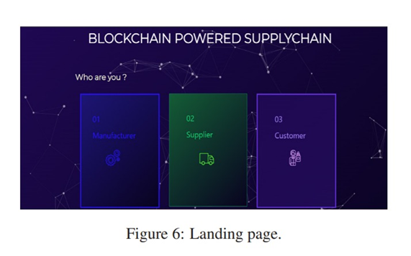

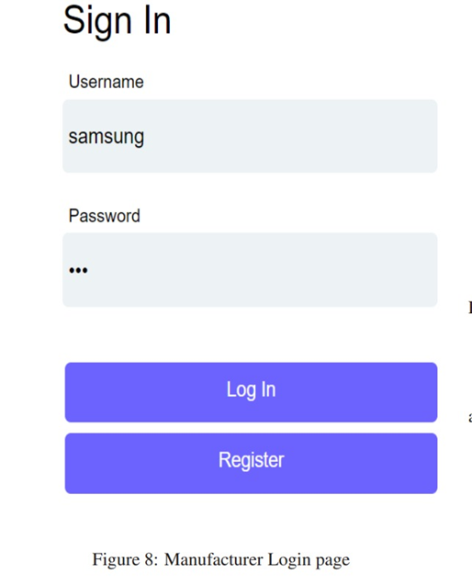

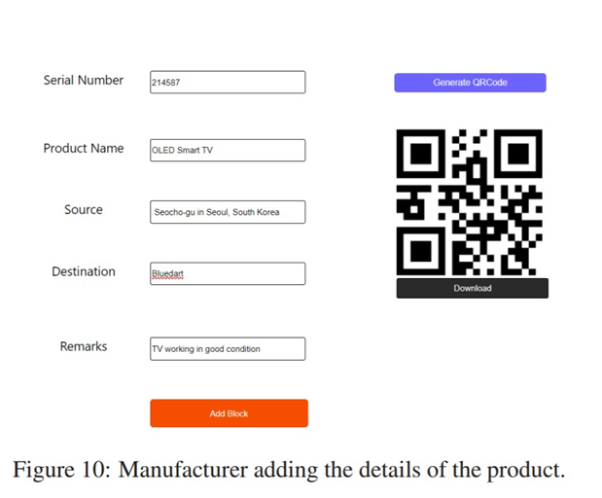

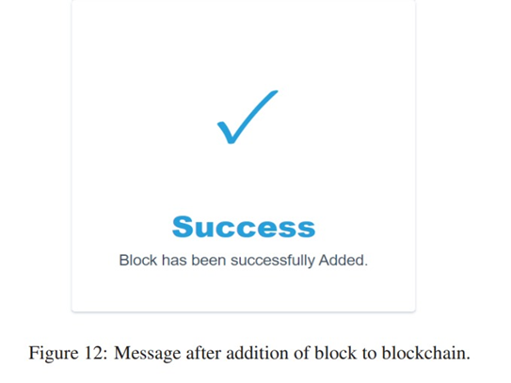

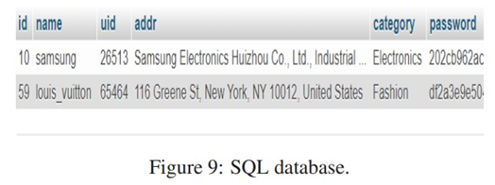

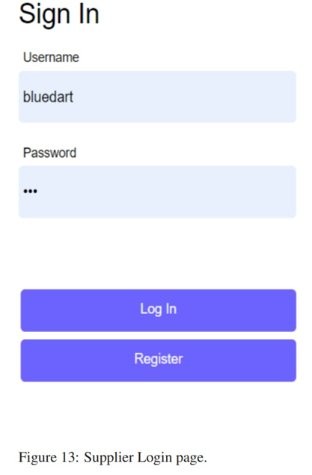

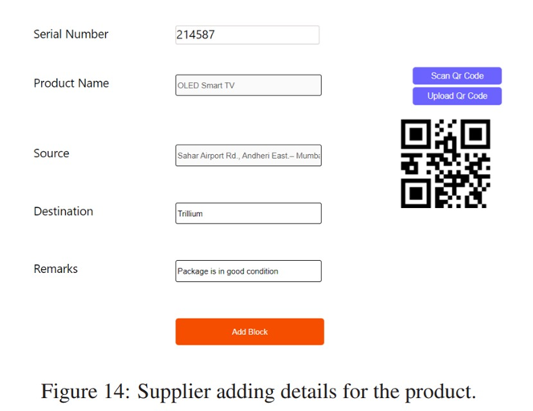

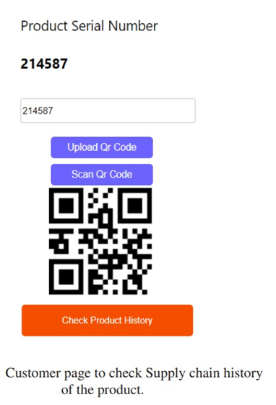

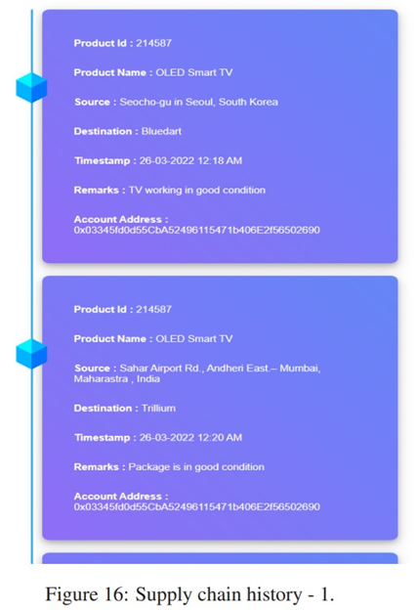

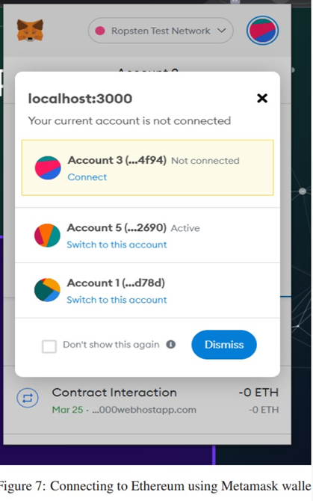

X. CONCLUSION & FUTURE SCOPE

The proposed blockchain-based anti-counterfeiting system introduces a secure, transparent, and cost-effective solution for businesses and consumers, ensuring product authenticity and trust in the supply chain. By leveraging Ethereum’s distributed applications (DApps) and the Web3.js library, the system provides a tamper-proof mechanism where manufacturers and suppliers can independently add transaction records without altering each other's data. The integration of MetaMask wallets ensures secure validation of transactions, while QR code verification allows end-users to authenticate products easily. This decentralized approach eliminates reliance on intermediaries, reducing fraud risks and improving operational efficiency in e-commerce and other industries.

To enhance the system’s performance and usability, several future improvements can be implemented. Optimizing the codebase will make the system more efficient, scalable, and user-friendly, allowing seamless adoption across industries. The integration of manufacturer and supplier APIs will enable real-time product data synchronization, ensuring instant verification and better inventory management. To prevent duplication, secure graphic QR codes with encryption techniques can be introduced, ensuring data integrity even in photocopied versions. The system’s scope can be expanded beyond e-commerce to industries like pharmaceuticals, food supply chains, and automotive sectors, enhancing counterfeit detection across multiple domains.

Interoperability with multiple blockchain networks, such as Hyperledger Fabric and Binance Smart Chain, can improve adoption and compatibility across different platforms.

Additionally, the development of a dedicated mobile application can enhance user experience, allowing consumers to scan QR codes, verify product authenticity, and receive real-time notifications regarding fraudulent products. By implementing these advancements, the system can revolutionize counterfeit prevention, ensuring a secure, transparent, and efficient trading environment in the digital economy.

# XI. REFERENCES

[1] Abhinav Sanghi, Aayush, Ashutosh Kata war, Anshul Arora, Aditya Kaushik, “Detecting Fake Drugs using Blockchain”, International Journal of Recent Technology and Engineering (IJRTE) ISSN: 2277-3878, Volume-10 Issue-1, May 2021.

[2]. Miguel A. Prada-Delgado, Gero Ditt mann, Ilie Circular, Jens Jelte “A blockchain-based crypto-anchor platform for interoperable product authentication”, EEE International Symposium on Circuits and Systems (ISCAS),2021.

[3]. Mrs. S. Thejaswini , Ranjitha K R, “Blockchain in Agriculture by using Decentralized Peer to Peer Networks”, Proceedings of the Fourth International Conference on Inventive Systems and Control (ICISC 2020),2020.

[4] S. Chen, R. Shi, Z. Ren, J. Yan, Y. Shi, J. Zhang, A blockchain-based supply chain quality management framework, in 2017 IEEE 14th International Conference on e-Business Engineering (ICEBE) (IEEE, 2017), pp. 172–176 .

[5] Vinayak Singla, Indra Kumar Malav, Jaspreet Kaur and Sumit Kalra, “Develop Leave Application using Blockchain Smart Contract”, 11th international conference on Communication Systems and Networks,2019.

[6] Jesus Maximo Montes, Cecilia E. Ramirez, Manuel Coronado Gutierrez, Victor M. Larios, “Smart Contracts for supply chain applicable to Smart Cities daily operations”5th IEEE International Smart Cities Conference (ISC2 2019), 2019.

[7] Sanjay K. S, Dr. Ajit Danti “Detection of fake opinions on online products using Decision Tree and Information Gain” Third International Conference on Computing Methodologies and Communication (ICCMC 2019),2019.

[8] Sanjay K. S, Dr. Ajit Danti “Detection of fake opinions on online products using Decision Tree and Information Gain” Third International Conference on Computing Methodologies and Communication (ICCMC 2019),2019.

[9] ASPA, The state of counterfeiting in india 2021, 20State % 20of % 20Counterfeiting % 20in % 20India % 202021.pdf (2021)

[10] F. Casino, T.K. Dasaklis, C. Patsakis, Telematics Informatics 36, 55 (2019) [12] M. Peck, IEEE Spectrum 54, 26 (2017) [13] S. Idrees, M. Nowostawski, R. Jameel, A. Mourya, Electronics 10, 951 (2021) [11] Zignuts Technolab, How blockchain architecture works? basic understanding of blockchain and its architecture., https : / / www.zignuts.com / blogs/ how - blockchain - architecture - works - basic - understanding- of- blockchain- and-its- architecture/ (2022)

[12] "Ethereum white paper," GitHub repository, 2013; V. Buterin et al.